ITA0601 – MACHINE LEARNING
LAB EXPERIMENTS
EXP-12: Iris Flower Classification using KNN
Dataset 1 – Basic Iris Dataset
Sepal Length | Sepal Width | Petal Length | Petal Width | Species
5.1 | 3.5 | 1.4 | 0.2 | Setosa
4.9 | 3.0 | 1.4 | 0.2 | Setosa
4.7 | 3.2 | 1.3 | 0.2 | Setosa
6.4 | 3.2 | 4.5 | 1.5 | Versicolor
6.9 | 3.1 | 4.9 | 1.5 | Versicolor
5.5 | 2.3 | 4.0 | 1.3 | Versicolor
6.3 | 3.3 | 6.0 | 2.5 | Virginica
5.8 | 2.7 | 5.1 | 1.9 | Virginica
7.1 | 3.0 | 5.9 | 2.1 | Virginica
Python Code:
from sklearn.neighbors import KNeighborsClassifier
X = [
[5.1, 3.5, 1.4, 0.2],
[4.9, 3.0, 1.4, 0.2],
[4.7, 3.2, 1.3, 0.2],
[6.4, 3.2, 4.5, 1.5],
[6.9, 3.1, 4.9, 1.5],
[5.5, 2.3, 4.0, 1.3],
[6.3, 3.3, 6.0, 2.5],
[5.8, 2.7, 5.1, 1.9],
[7.1, 3.0, 5.9, 2.1]
]
y = [
"Setosa", "Setosa", "Setosa",
"Versicolor", "Versicolor", "Versicolor",
"Virginica", "Virginica", "Virginica"
]
knn = KNeighborsClassifier(n_neighbors=3)
knn.fit(X, y)
new_flower = [[5.0, 3.4, 1.5, 0.2]]
prediction = knn.predict(new_flower)
print("Predicted Flower:", prediction[0])
Output:
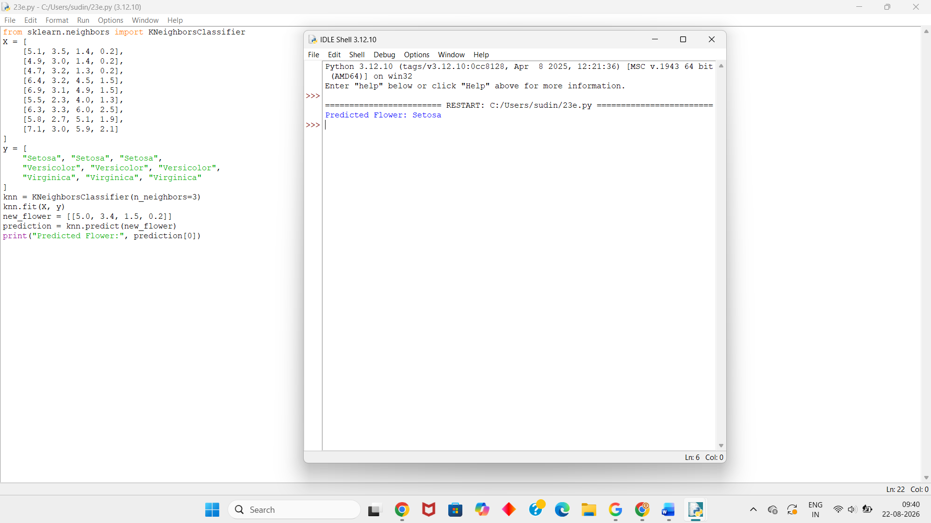
Dataset 2 – Iris Dataset
Sepal Length | Sepal Width | Petal Length | Petal Width | Species
5.0 | 3.4 | 1.5 | 0.2 | Setosa
4.6 | 3.1 | 1.5 | 0.2 | Setosa
5.4 | 3.7 | 1.5 | 0.2 | Setosa
5.9 | 3.0 | 4.2 | 1.5 | Versicolor
6.0 | 2.9 | 4.5 | 1.5 | Versicolor
6.1 | 2.8 | 4.0 | 1.3 | Versicolor
6.5 | 3.0 | 5.2 | 2.0 | Virginica
6.2 | 3.4 | 5.4 | 2.3 | Virginica
6.7 | 3.1 | 5.6 | 2.4 | Virginica
Python Code:
from sklearn.neighbors import KNeighborsClassifier
X = [
[5.0, 3.4, 1.5, 0.2],
[4.6, 3.1, 1.5, 0.2],
[5.4, 3.7, 1.5, 0.2],
[5.9, 3.0, 4.2, 1.5],
[6.0, 2.9, 4.5, 1.5],
[6.1, 2.8, 4.0, 1.3],
[6.5, 3.0, 5.2, 2.0],
[6.2, 3.4, 5.4, 2.3],
[6.7, 3.1, 5.6, 2.4]
]
y = [
"Setosa", "Setosa", "Setosa",
"Versicolor", "Versicolor", "Versicolor",
"Virginica", "Virginica", "Virginica"
]
knn = KNeighborsClassifier(n_neighbors=3)
knn.fit(X, y)
new_flower = [[5.2, 3.5, 1.4, 0.2]]
prediction = knn.predict(new_flower)
print("Predicted Flower:", prediction[0])
Output:
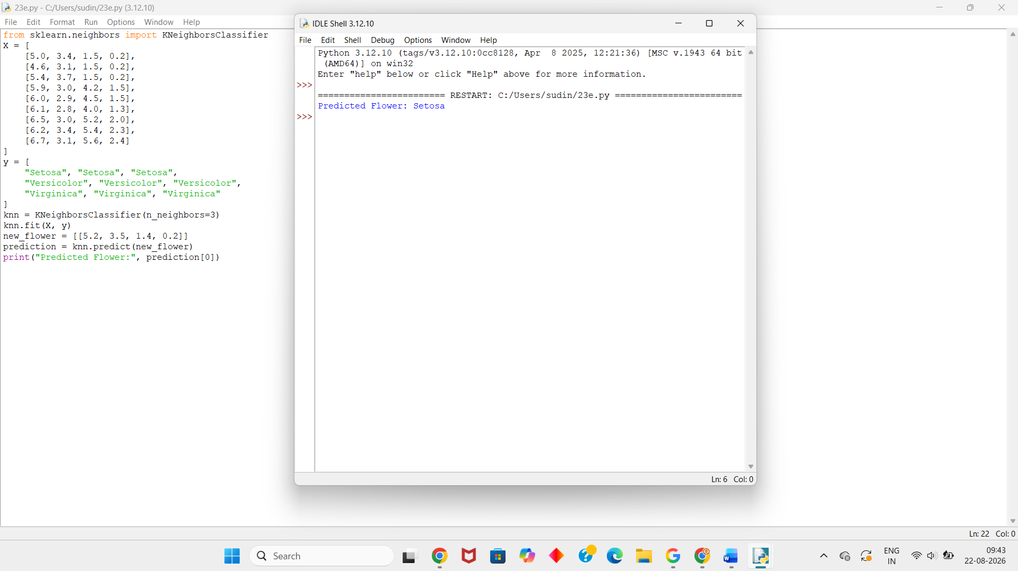
Dataset 3 – Iris Dataset
Sepal Length | Sepal Width | Petal Length | Petal Width | Species
5.2 | 3.4 | 1.4 | 0.2 | Setosa
4.8 | 3.4 | 1.6 | 0.2 | Setosa
5.1 | 3.8 | 1.6 | 0.2 | Setosa
6.0 | 2.7 | 5.1 | 1.6 | Versicolor
5.6 | 2.9 | 3.6 | 1.3 | Versicolor
5.7 | 2.8 | 4.5 | 1.3 | Versicolor
6.8 | 3.2 | 5.9 | 2.3 | Virginica
6.4 | 2.8 | 5.6 | 2.2 | Virginica
6.9 | 3.1 | 5.4 | 2.1 | Virginica
Python Code:
from sklearn.neighbors import KNeighborsClassifier
X = [
[5.2, 3.4, 1.4, 0.2],
[4.8, 3.4, 1.6, 0.2],
[5.1, 3.8, 1.6, 0.2],
[6.0, 2.7, 5.1, 1.6],
[5.6, 2.9, 3.6, 1.3],
[5.7, 2.8, 4.5, 1.3],
[6.8, 3.2, 5.9, 2.3],
[6.4, 2.8, 5.6, 2.2],
[6.9, 3.1, 5.4, 2.1]
]
y = [
"Setosa", "Setosa", "Setosa",
"Versicolor", "Versicolor", "Versicolor",
"Virginica", "Virginica", "Virginica"
]
knn = KNeighborsClassifier(n_neighbors=3)
knn.fit(X, y)
new_flower = [[6.1, 2.9, 4.7, 1.4]]
prediction = knn.predict(new_flower)
print("Predicted Flower:", prediction[0])
Output:
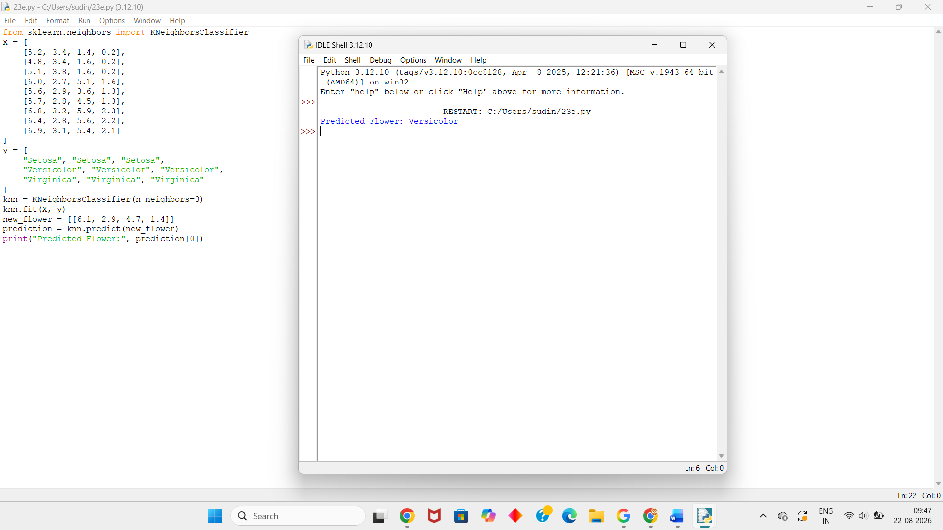

Dataset 4 – Iris Dataset
Sepal Length | Sepal Width | Petal Length | Petal Width | Species
5.3 | 3.7 | 1.5 | 0.2 | Setosa
5.0 | 3.0 | 1.6 | 0.2 | Setosa
4.7 | 3.2 | 1.6 | 0.2 | Setosa
5.8 | 2.7 | 4.1 | 1.0 | Versicolor
6.2 | 2.2 | 4.5 | 1.5 | Versicolor
5.5 | 2.5 | 4.0 | 1.3 | Versicolor
6.7 | 3.3 | 5.7 | 2.1 | Virginica
6.3 | 2.9 | 5.6 | 1.8 | Virginica
7.2 | 3.2 | 6.0 | 1.8 | Virginica
Python Code:
from sklearn.neighbors import KNeighborsClassifier
X = [
[5.3, 3.7, 1.5, 0.2],
[5.0, 3.0, 1.6, 0.2],
[4.7, 3.2, 1.6, 0.2],
[5.8, 2.7, 4.1, 1.0],
[6.2, 2.2, 4.5, 1.5],
[5.5, 2.5, 4.0, 1.3],
[6.7, 3.3, 5.7, 2.1],
[6.3, 2.9, 5.6, 1.8],
[7.2, 3.2, 6.0, 1.8]
]
y = [
"Setosa", "Setosa", "Setosa",
"Versicolor", "Versicolor", "Versicolor",
"Virginica", "Virginica", "Virginica"
]
knn = KNeighborsClassifier(n_neighbors=3)
knn.fit(X, y)
new_flower = [[6.0, 2.8, 5.1, 1.8]]
prediction = knn.predict(new_flower)
print("Predicted Flower:", prediction[0])
Output:
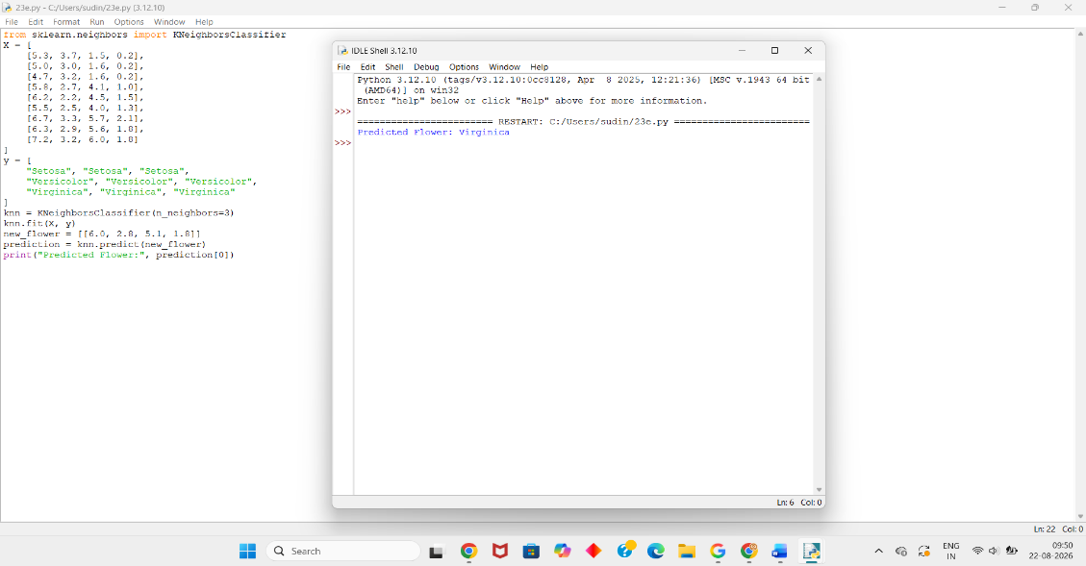
Dataset 5 – Iris Dataset
Sepal Length | Sepal Width | Petal Length | Petal Width | Species
5.4 | 3.4 | 1.7 | 0.2 | Setosa
4.9 | 3.1 | 1.5 | 0.1 | Setosa
5.1 | 3.5 | 1.4 | 0.3 | Setosa
5.7 | 2.9 | 4.2 | 1.3 | Versicolor
6.3 | 2.5 | 4.9 | 1.5 | Versicolor
5.8 | 2.6 | 4.0 | 1.2 | Versicolor
6.4 | 3.1 | 5.5 | 1.8 | Virginica
6.9 | 3.2 | 5.7 | 2.3 | Virginica
7.3 | 2.9 | 6.3 | 1.8 | Virginica
Python Code:
from sklearn.neighbors import KNeighborsClassifier
X = [
[5.4, 3.4, 1.7, 0.2],
[4.9, 3.1, 1.5, 0.1],
[5.1, 3.5, 1.4, 0.3],
[5.7, 2.9, 4.2, 1.3],
[6.3, 2.5, 4.9, 1.5],
[5.8, 2.6, 4.0, 1.2],
[6.4, 3.1, 5.5, 1.8],
[6.9, 3.2, 5.7, 2.3],
[7.3, 2.9, 6.3, 1.8]
]
y = [
"Setosa", "Setosa", "Setosa",
"Versicolor", "Versicolor", "Versicolor",
"Virginica", "Virginica", "Virginica"
]
knn = KNeighborsClassifier(n_neighbors=3)
knn.fit(X, y)
new_flower = [[6.5, 3.0, 5.5, 1.8]]
prediction = knn.predict(new_flower)
print("Predicted Flower:", prediction[0])
Output:
